**Data Warehouse Reporting**

**Scenario:**

You are a data engineer hired by an ecommerce company named SoftCart.com . The company retails download only items like E-Books, Movies, Songs etc. The company has international presence and customers from all over the world. You have designed the schema for the data warehouse in the previous assignment. Data engineering is a team game. Your senior data engineer reviewed your design. Your schema design was improvised to suit the production needs of the company. In this assignment you will generate reports out of the data in the data warehouse.

**Objectives:**

In this assignment you will:

* Load data into Data Warehouse
* Write aggregation queries
* Create MQTs

**Tools / Software:**

Cloud instance of IBM DB2 database

**Prerequisites:**

You need access to a cloud instance of IBM DB2 to proceed with this assignment.

**Exercise 1 - Load data into the Data Warehouse**

You will load the data provided by the company in csv format.

Task 1 - Load data into the dimension table DimDate

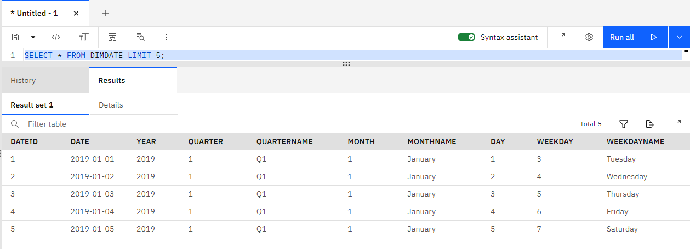

Task 2 - Load data into the dimension table DimCategory

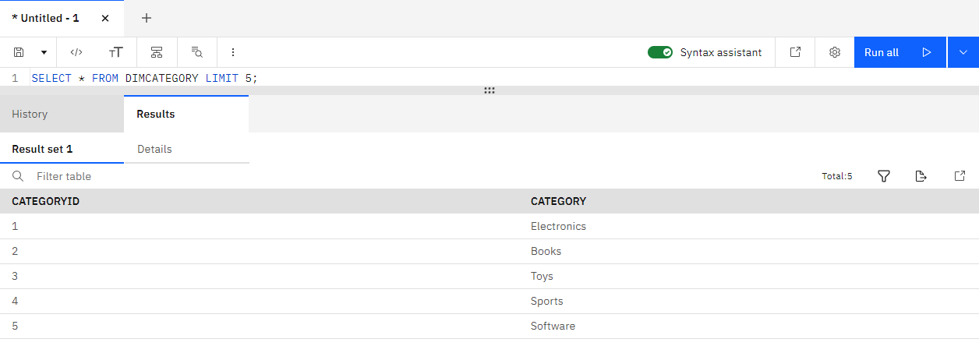

Task 3 - Load data into the dimension table DimCountry

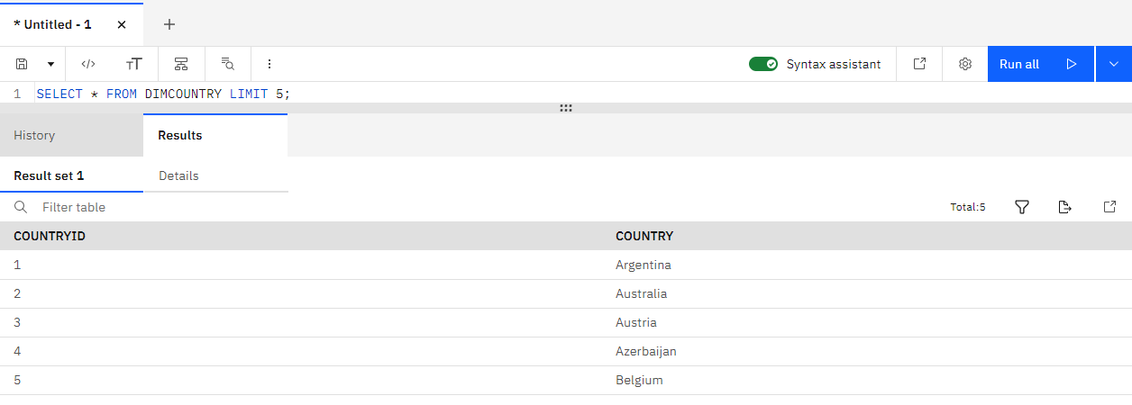

Task 4 - Load data into the fact table FactSales

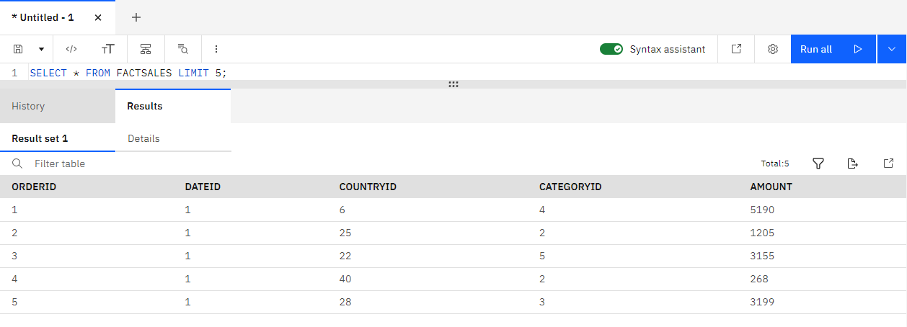

**Exercise 2 - Queries for data analytics**

In this exercise you will query the data you have loaded in the previous exercise.

Task 5 - Create a grouping sets query

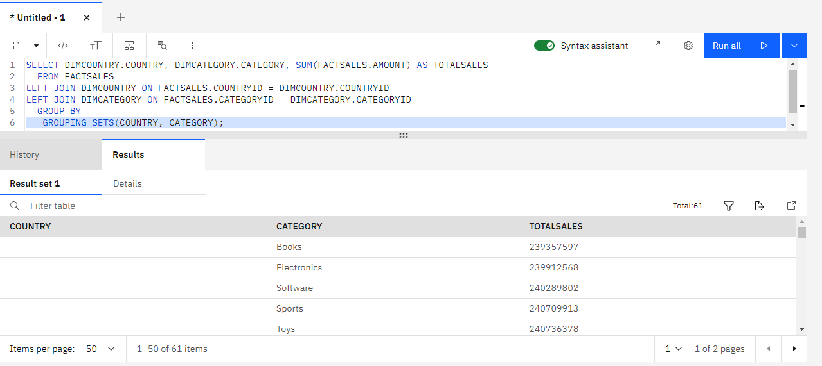

Task 6 - Create a rollup query

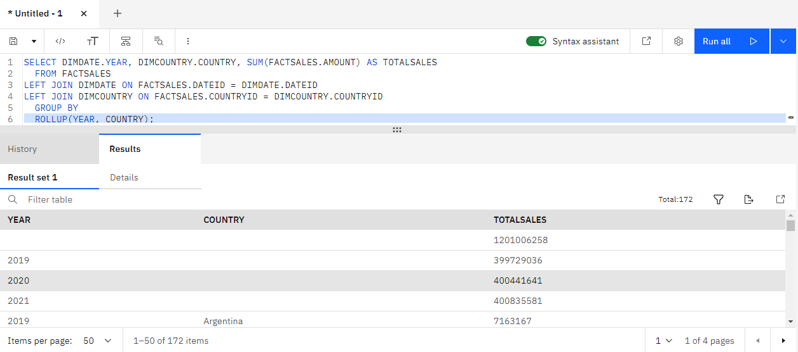

Task 7 - Create a cube query

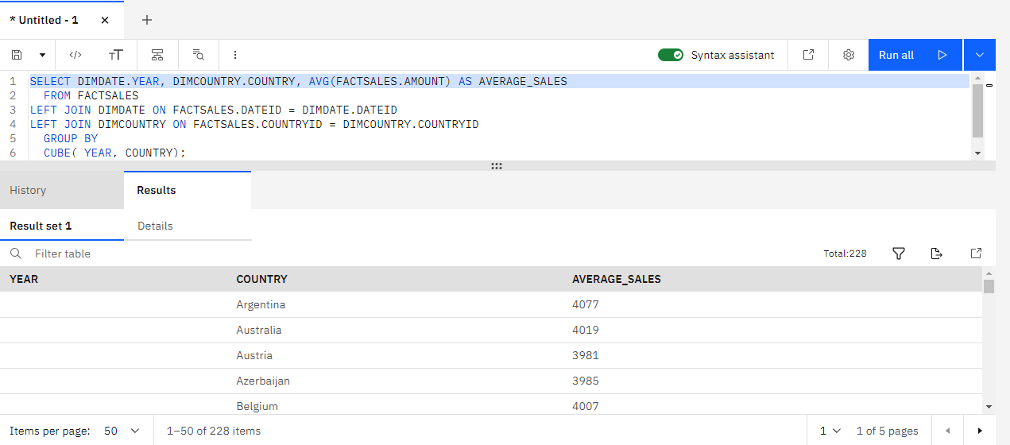

Task 8 - Create an MQT

